**BIODATA**

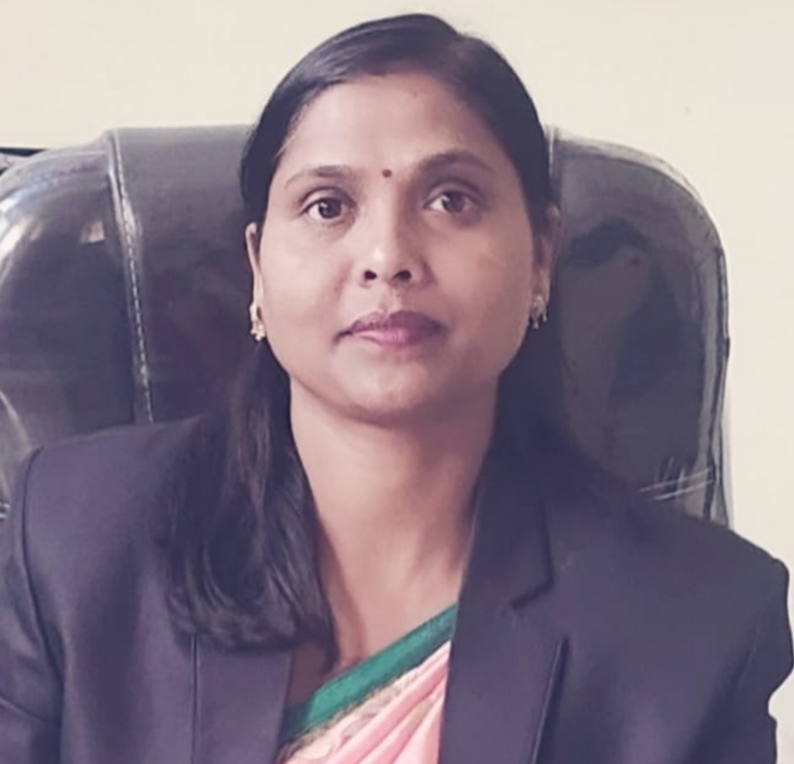

Name ;- Sharda Darro

Husband’s Name ;- Shri Kamal Singh Darro

Date of Appointment ;-29/11/2012,

& Place Govt. Arvind College Kirandul, Distt- Dantewada

Contact No ;- 9165211298

Academic Carrier ;-

|  |  |  |  |  |
| --- | --- | --- | --- | --- |
| **S.No.** | **Board/University** | **Year of Passing** | **Percentage** | **Division** |
| 10th | CBSE | 1994 | 55.5 | 2nd |
| 12th | CBSE | 1996 | 51.6 | 2nd |
| BSC | Pt. RSU Raipur | 1999 | 55.4 | 2nd |
| BEd | Rani Durgawati University | 2000 | 64.4 | 1st |
| MSc. | Pt. RSU Raipur | 2002 | 64.8 | 1st |
| M.A Sociology | Bastar University, Jagdalpur | 2009 | 63.7 | 1st |
| SET |  | 2006 |  |  |

**Professional Carrier** ;-

1. Guest lecturer from 20003-2004 on adhoc basis, Govt. Arvind College Kirandul
2. PGT Biology from 2004 to 2006 on adhoc basis, Kendriya Vidalaya Kirandul
3. Jr. Asst. Gr-III, from 2007 to 2012 NMDC Limited Kirandul Complex (CG)
4. Asst. Professor of Govt. Arvind College Kirandul, From 2012 ….(recruitment though PSC).
5. I/C Principal of Govt. Arvind College Kirandul, from 2018 ….

**Refresher/Orientation/Training :**

1. Orientation Program attended Pt. Ravishankar Shukla University Raipur from 03.06.2014 to 30.06.2014.
2. Refresher program – HRDC Guru Ghasidas Vishwavidyalaya. Bilasur from 27.05.2016 to 16.06.2016.
3. Parichayatmak Prasikchhan Program from Chhatisgarh Prasan Acadami nimora Raipur Date 14.10.2019 to 08.11.2019.

**Seminar/Workshop/Conference attended:**

1. Vartman Shiksha Vyastha : Chunotiyan evam Samadhan. Date 21-22 Jun 2014 Raipur.
2. Traditional and Tribal Knowledge of India and its Relevance in Present Scenario. Date 6-7 February 2015 Govt. Kaktiya P.G. College, Jagdalpur.
3. Challenges of human resource development in Tribal areas Date 16-17 January 2015 Department of Economics and psychology Govt. Dantewada P.G. College Dantewada.
4. Contribution of Ancient Indian Mathematician & Its Uses in Present Age Department of Mathematics Govt. Dr. B.S.B.A. College, Dongargaon Date 22-23 January 2016.
5. Sansadhan evam Pradeshik Vikash Dr. C.V. Raman University Kota, & Chhattisgarh Bhugol Parishad Date 22-23 January 2018.
6. Advance and globalization of chemical science for man material & environment. The Society for Promotion of material science (SPMS) Nagpur Date 9-10 March 2018.
7. Recent trends and development in Science for Humanity Govt. E. Raghvendra Rao PG Science College Raipur Date 13-14 January 2019.
8. An interdisciplinary study on carbon management & sustainable development Govt. Arvind College Kirandul, Dantewada (C.G.) 01-02- February 2019.
9. Medicinal and Aromatic Plants for Boosting immunity in the ara of COVID-19 19 May 2020.
10. Five Days National Workshop (Online) on instrumentation Govt. Arvind College Kirandul, Dantewada Date 05 July 2021 to 09 July 2021.
11. Advanced Opportunities and implicit research technologies in science Govt. Arvind College Kirandul 7- 12 June 2021.
12. Research Methodology & thesis writing Govt. Arvind College Kirandul 4 October 2020.

**Seminar/ Conference/ Symposium Organized :**

Patron;- National Seminar An interdisciplinary study on carbon management & sustainable development Govt. Arvind College Kirandul, Dantewada (C.G.) 01-02- February 2019.

Petron;- National Webinar on Science and technology driven higher education in state of Chhattisgarh: Challeges and opportunity during and after covid pandemic . 15 july 2020 Govt. Arvind College Kirandul.

Petron;- National Webinar Reseach methodology dated 11 august 2021.